Technical Project Charter: Lewis Retail Engine - Integration & Revenue Audit
Project Phase: Retail Systems & Transactional Integrity
TEAM MEMBERS: SACHIN KIRSTEN BROWN AND MOEGAMAT YOUSHA DIEDERICKS
2026
Project Phase: Retail Systems & Transactional Integrity
Sprint Duration: 30 Days
Team Structure: 3-Person Quality Engineering Squad
Target Systems: Lewis Retail API (Node.js), Lewis SQL Database

Task 1:
  - Database Initialization:
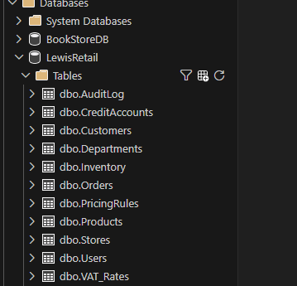
- Database initialized.
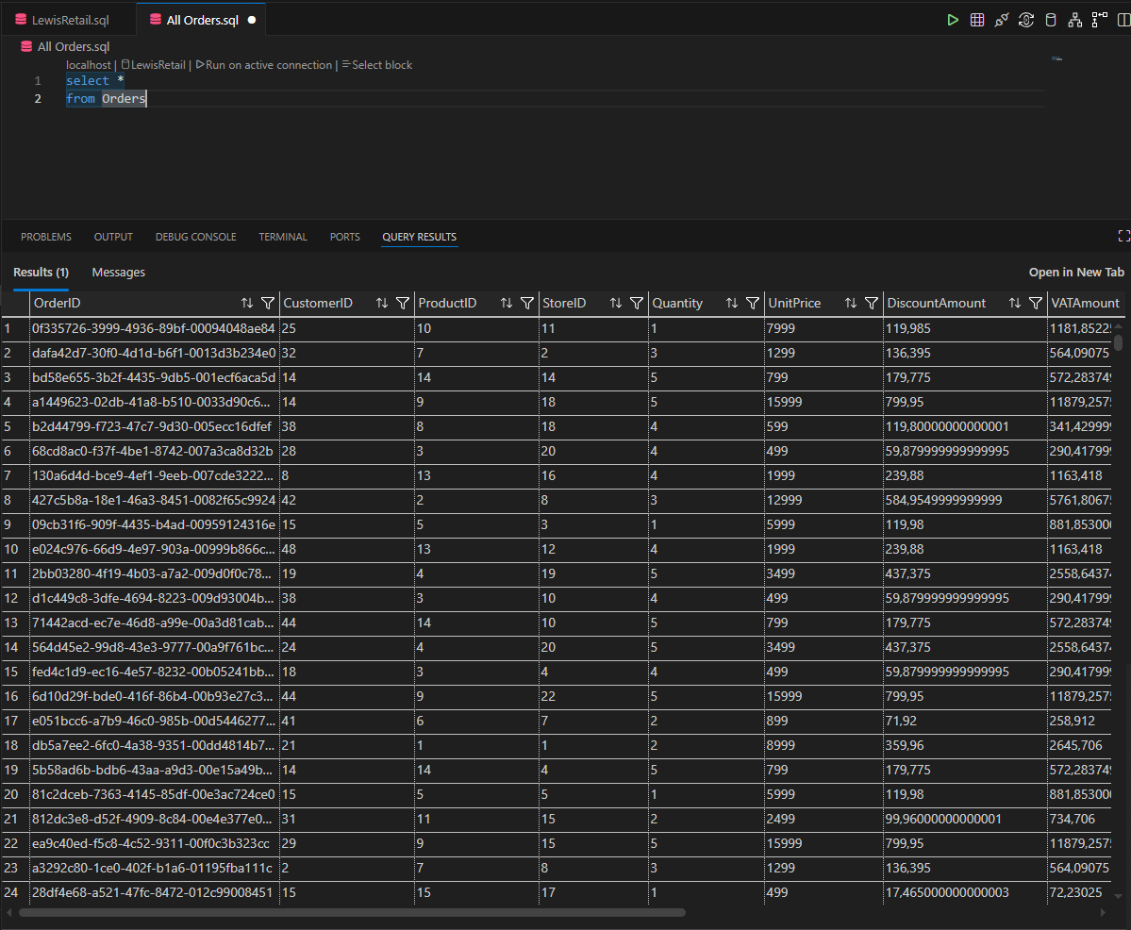
- 5,000+ stock and pricing records initialized.

  - API Deployment
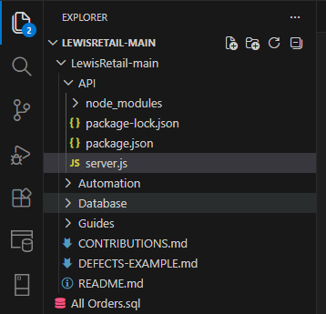
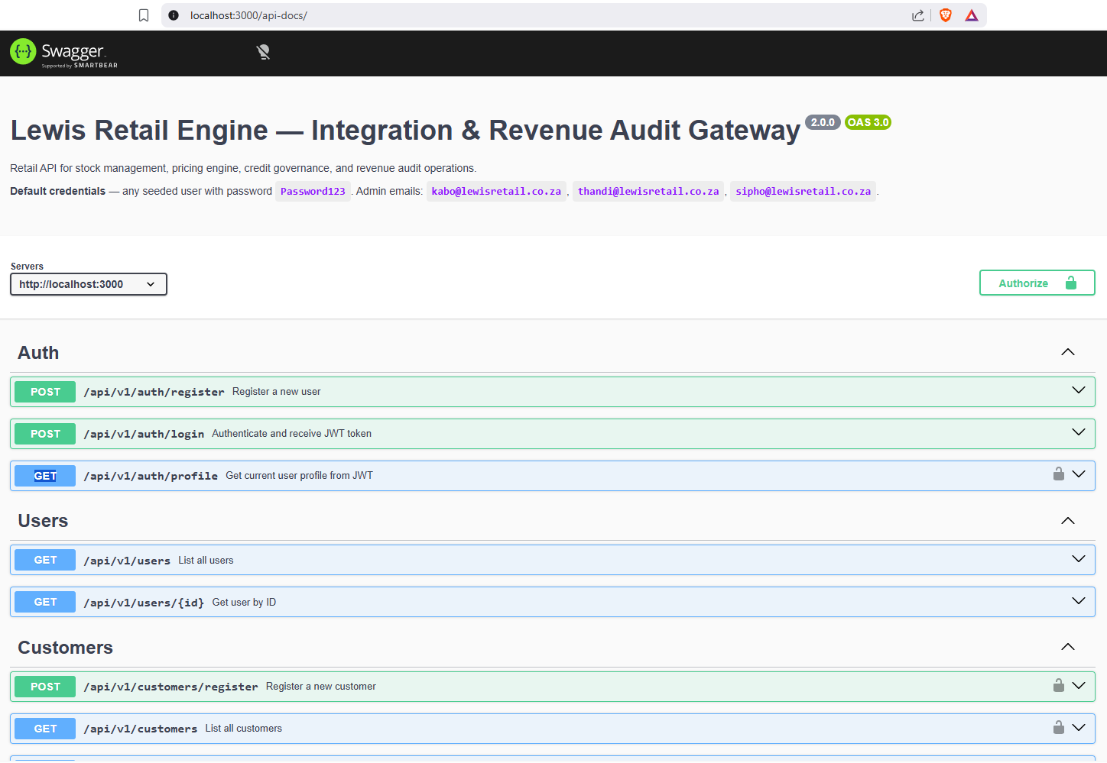
- Api was deployed.

  - JIRA Project Management
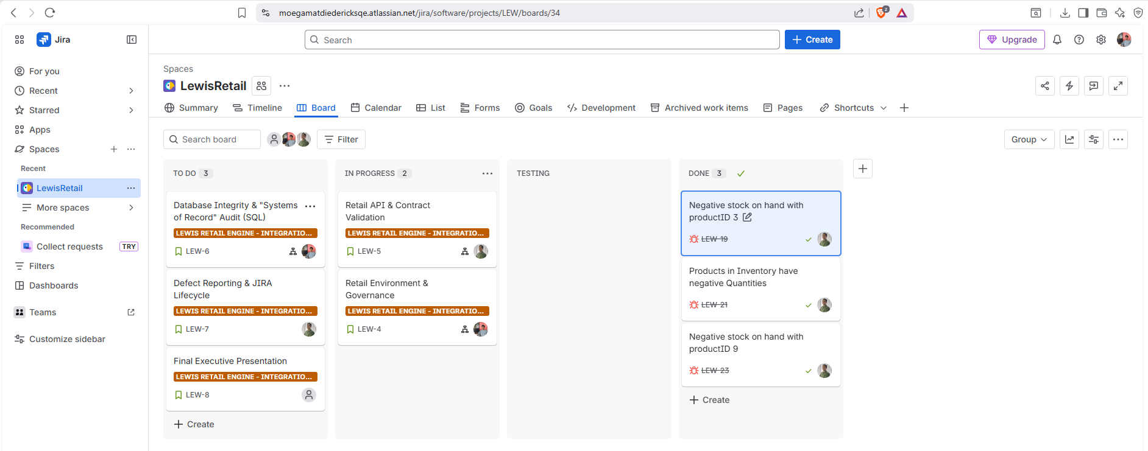
- JIRA space created with Epics and Subtasks, with subtasks assigned to team members.

  - Git Architecture
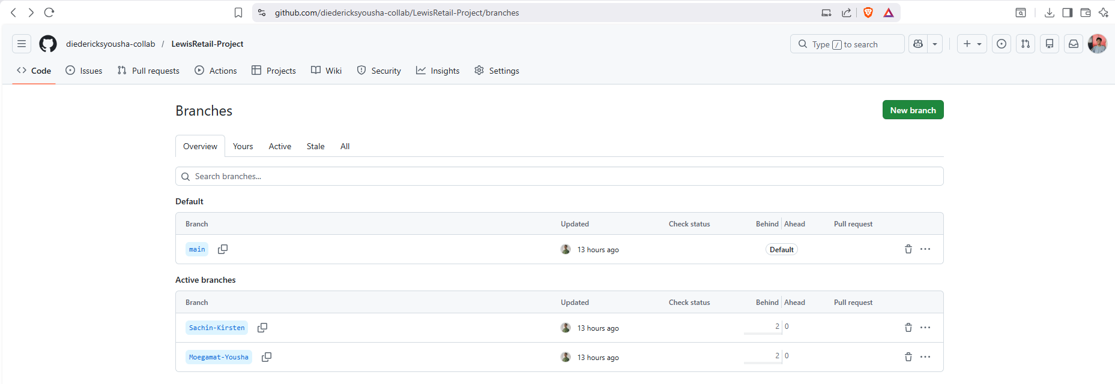
- Branches are active and shared repository created in GitHub.
Task 1 Answer
The integration of JIRA and Git supports traceability by creating a clear link between requirements, development work, testing, defects, and fixes. In a retail environment, when a pricing defect is discovered in production, the team must quickly identify where the problem started and how it can be corrected. JIRA records the user story, sub-task, or bug ticket related to the pricing feature, including reproduction steps, expected and actual results, screenshots, and test evidence. Git provides the technical history by showing the exact branch, commit, and pull request where the pricing logic was added or changed. By linking JIRA tickets to Git branches and pull requests, the team can trace the defect from the original business requirement to the specific code change that caused the issue, and then to the final fix. This improves accountability, speeds up root cause analysis, supports auditing, and reduces the risk of repeated pricing errors in a high-stakes retail system.

